7/1/2026
Allied Software Engineers
Cyber Security Internship
Task 01

Abdul Rehman

Scenario 1: Linux User & File Permission Security
- Open Linux terminal.
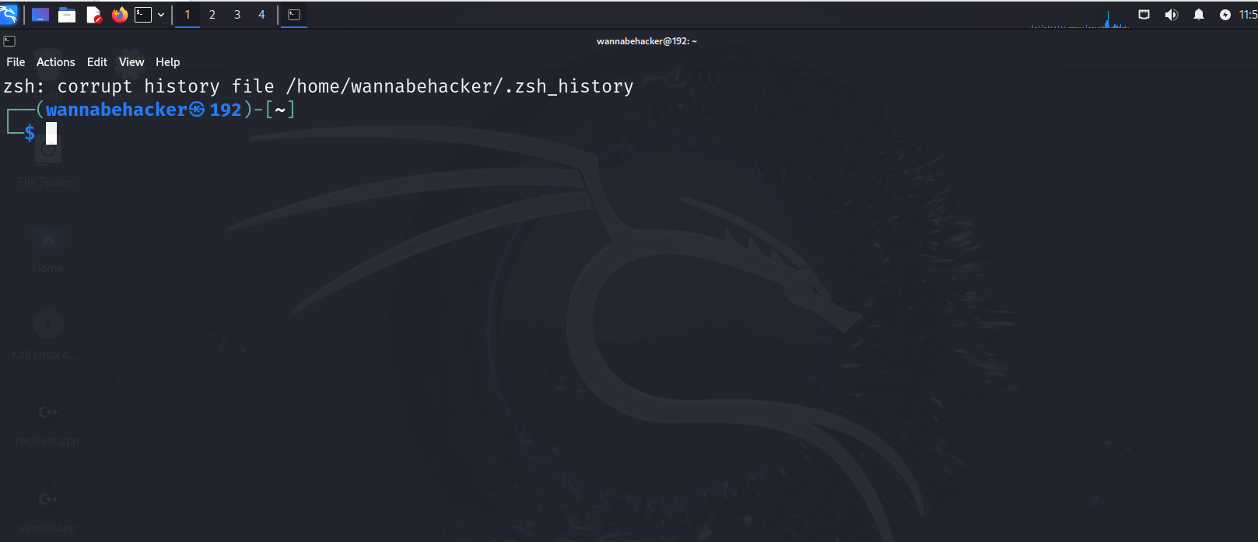

- Create a folder named cyber_lab_01
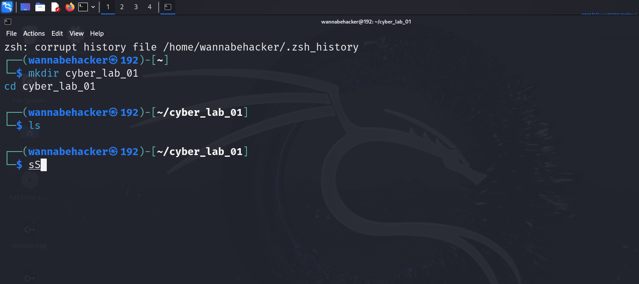

- Inside it, create folders
- public
- private
- logs
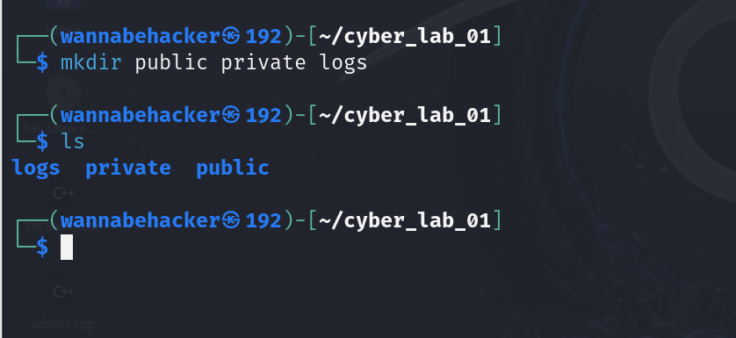
Created the Folders and here’s the proof as well.
- Create a file student_info.txt
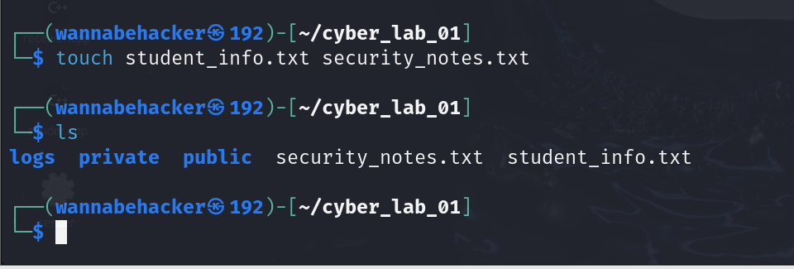

- Add your name, domain, and supervisor name inside the file
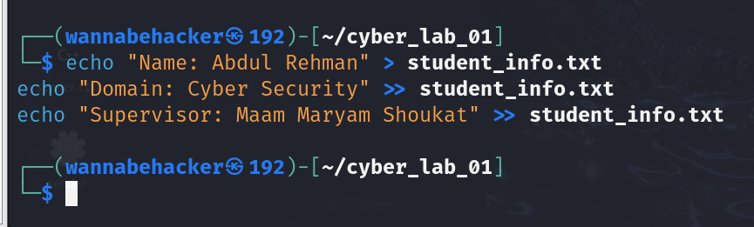
- Write 5 basic cyber security tips in it
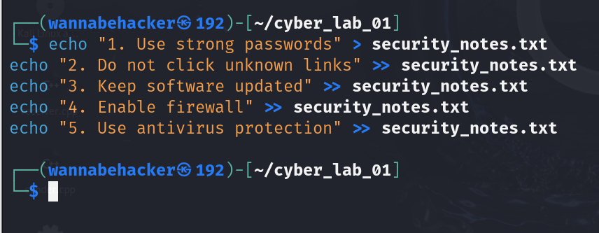

- Show current directory using pwd
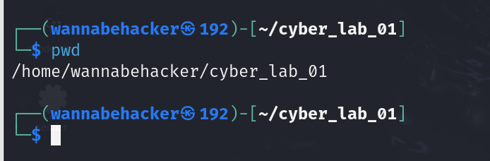

- List files using ls.
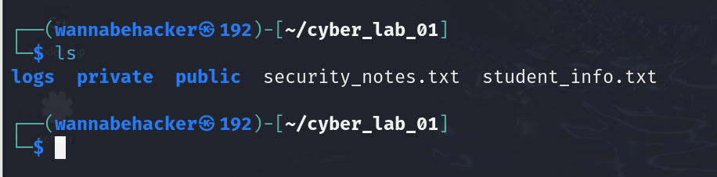

- Show hidden files using ls -a
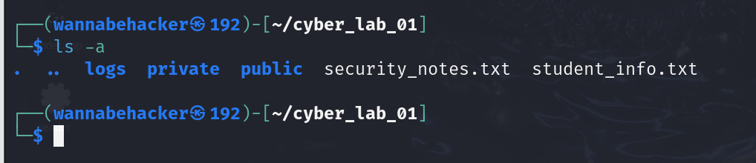

- Change permission of private folder
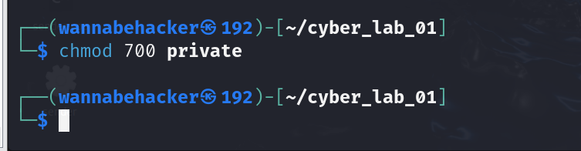

- Change permission of public folder
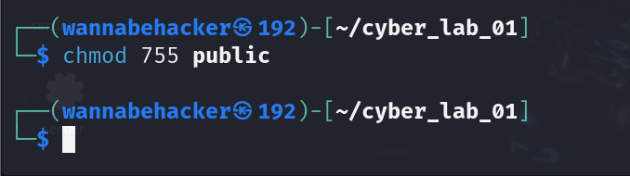

- Display permissions using ls -l
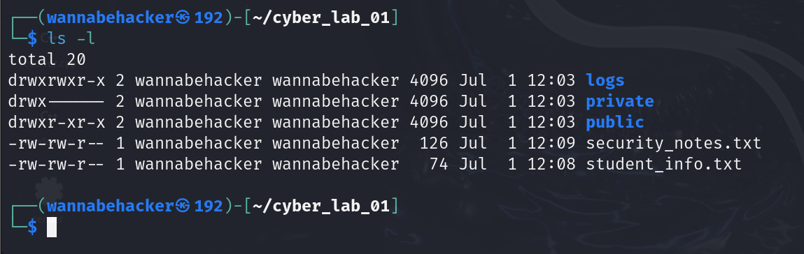
This shows a line like drwx------ for private and drwxr-xr-x for public.

- Create a backup file named student_info_backup.txt
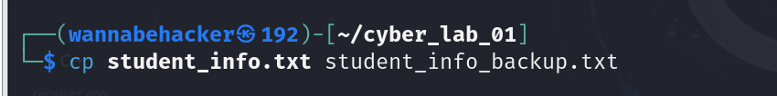

- Display file content using cat
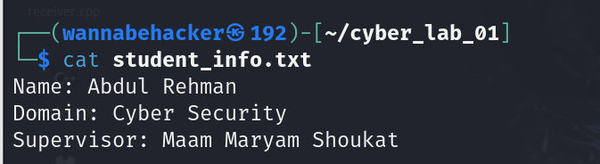

Scenario: The company wants a simple beginner-level Python script that checks whether an intern’s password is weak or strong.
- Create a Python file named:
- password_checker.py
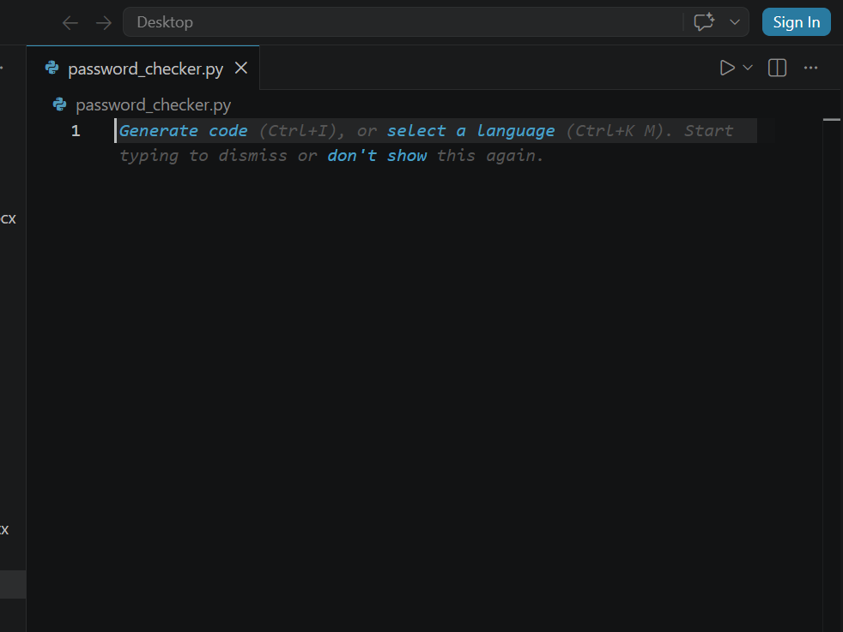

- Code running in the terminal
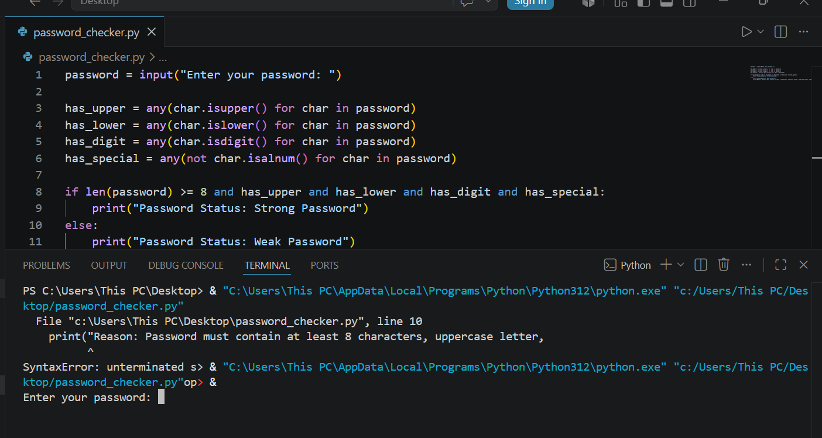

- Output with one strong password
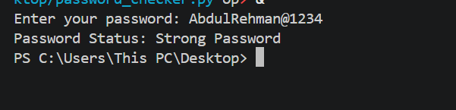

- Output with weak password
Test case with small letters, special characters and numbers.

Test case with only alphabets.

